QUIZ

<https://forms.gle/oUsFzJTHWZEmFQZMA>

Questions: VAS DATA

## In a randomized control trial, 32 patients were divided into two groups: A and B. Group A received test drug whereas group B received placebo. The variable of interest was ‘Change in pain level’ measured by visual analogue scale (VAS)’ before treatment and after 3 days of treatment.

## Visualize baseline VAS score (VAS_before) by treatment group.

## Obtain measures of central tendency and variation for VAS_before by treatment group.

## Derive a new variable- Change from baseline after 3 days of treatment

1. Visualize the change from baseline by treatment group
2. Derive a new variable indicating 20 points drop in VAS score from baseline
3. Obtain cross table of above indicator variable with treatment group
4. Visualize the relationship between Change from baseline and baseline score
5. Obtain correlation coefficient between Change from baseline and baseline score

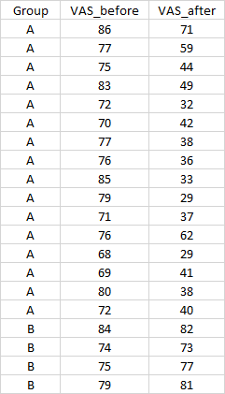

**#Use csv data file VAS DATA**

********************************************************